Experiment: JWT Authentication in ASP.NET Core Web API
Aim
To implement JWT (JSON Web Token) Authentication in an ASP.NET Core Web API application and secure API endpoints using the Authorize attribute.

Objectives
- Create an ASP.NET Core Web API project.
- Create a LoginModel class.
- Create an AuthController with a login endpoint.
- Generate a JWT token after successful login.
- Secure an API endpoint using the [Authorize] attribute.
- Test the API using Swagger.

Procedure
- Created a new ASP.NET Core Web API project in Visual Studio.
- Created a LoginModel class containing Username and Password properties.
- Added JWT configuration in appsettings.json.
- Configured JWT Authentication and Authorization in Program.cs.
- Created an AuthController.
- Added a POST /api/Auth/login action method.
- Validated the username and password.
- Generated a JWT token for valid credentials.
- Added a secured GET /api/Auth/secure endpoint using the [Authorize] attribute.
- Executed the application and tested the APIs using Swagger.

Output
Screenshot 1: Swagger Home Page

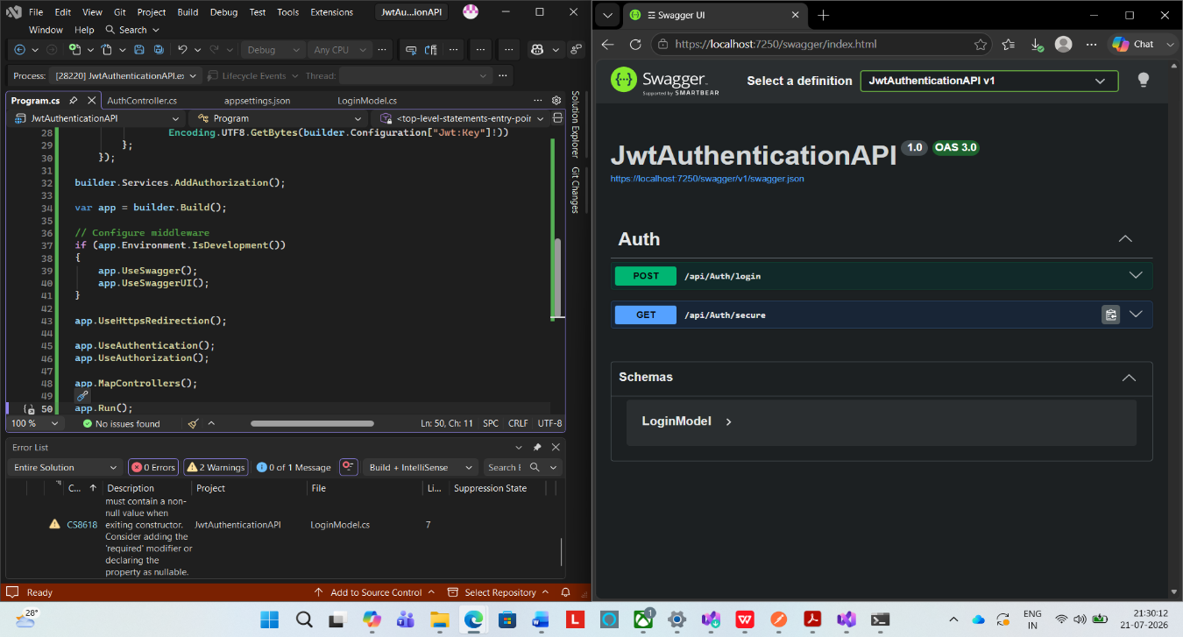

Screenshot 2: POST Login Request
Username: admin; Password: admin123;
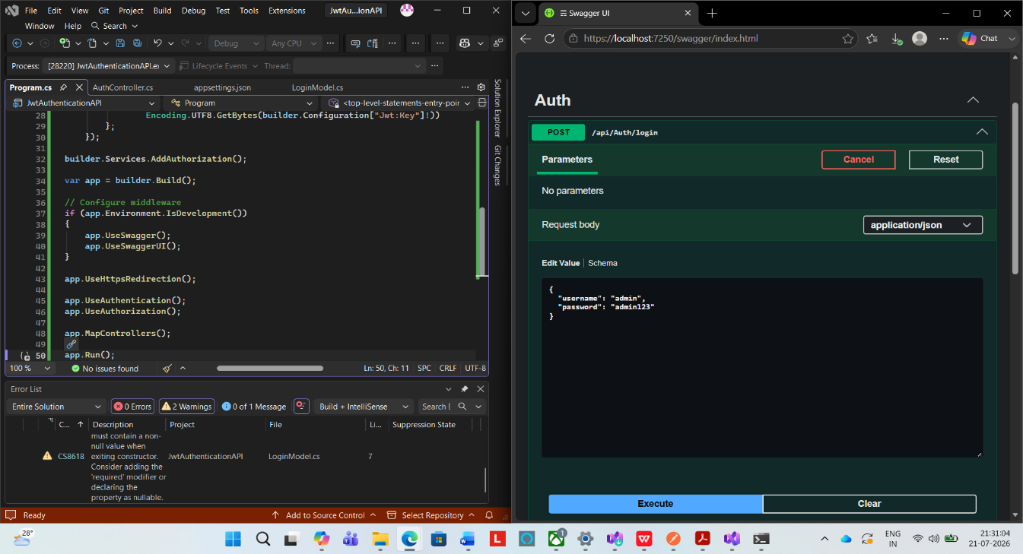

Screenshot 3
JWT Token Generated Successfully
Response: 200 OK
A JWT token was generated successfully after entering valid credentials.
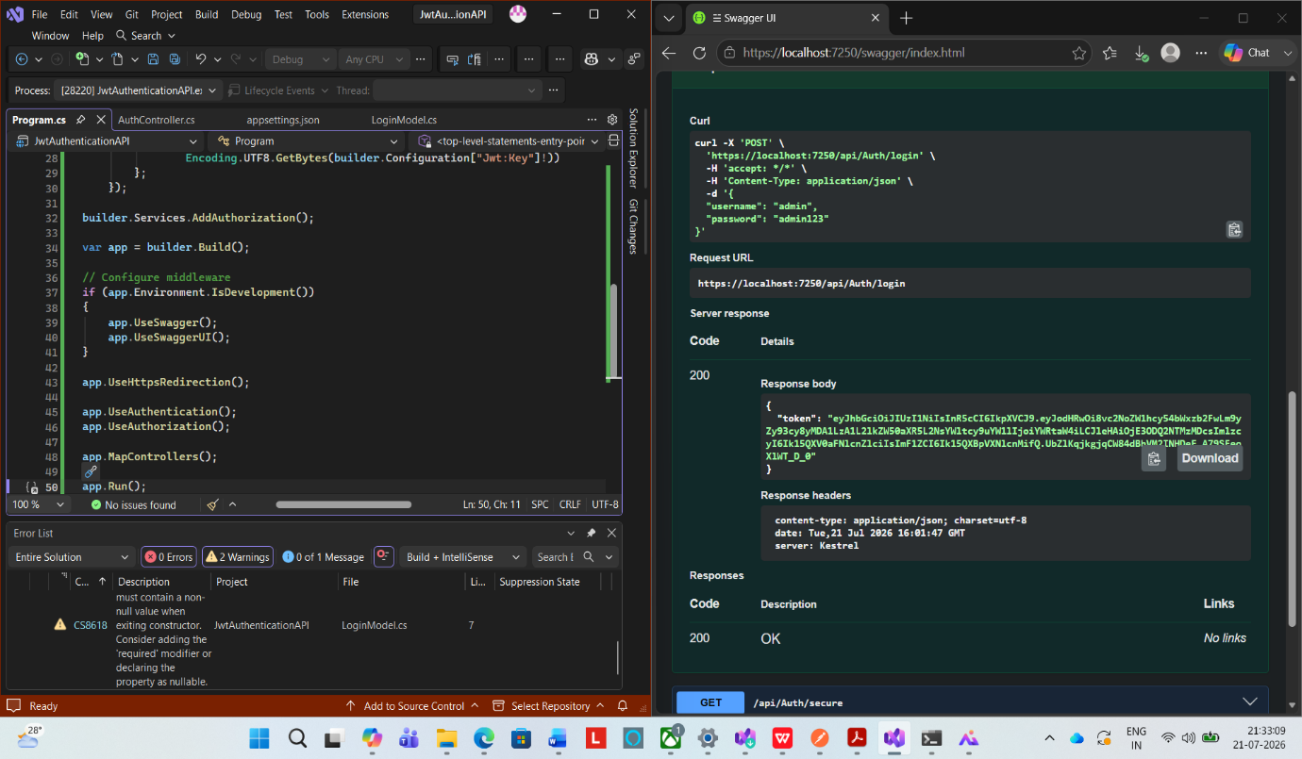

Screenshot 4
Secure API Request: The GET /api/Auth/secure endpoint was executed without passing the JWT token.
Response: 401 Unauthorized
This confirms that the endpoint is protected and can only be accessed after authentication.

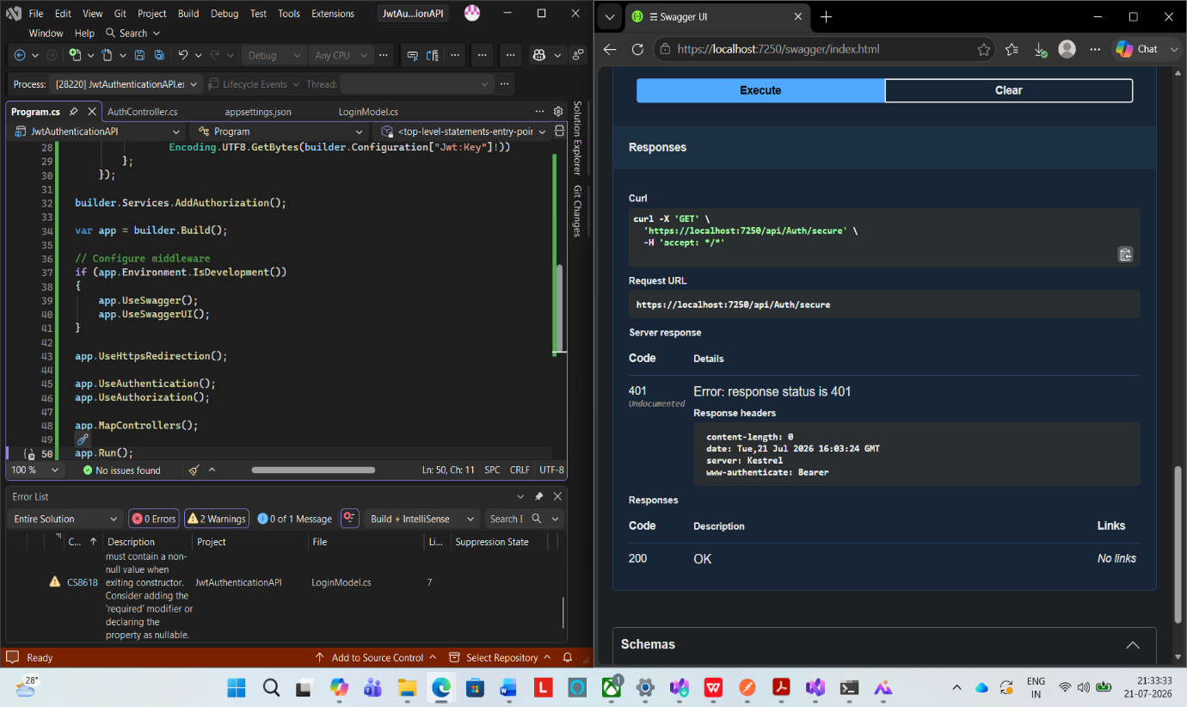

Result
JWT Authentication was implemented successfully in the ASP.NET Core Web API application. The login API generated a valid JWT token for authenticated users, and the protected API endpoint required authorization before allowing access, demonstrating successful implementation of authentication and authorization.

